 | Namal University Mianwali  Department of Computer Science

DAV Project Phase 3
Data Cleaning (Missing Values, Duplicates, Outliers)

Course | Phase Lead | Group Members | Department
Data Analysis and Visualization | Usaira Shahbaz (NUM-BSCS-2022-27) | Malik Zaheer Abbas (NUM-BSCS-2022-50)  Ahmad Mustafa (NUM-BSCS-2022-37) | Computer Science, Namal University, Mianwali

Step 1: Import and Initial Cleaning
Objective: Load the dataset and remove irrelevant or redundant features.
import pandas as pd
df = pd.read_csv("/content/FINAL.csv")
df.drop(columns=['review_comment_title'], inplace=True)
Removed the review_comment_title column as it added no analytical value and had excessive missing values.

Step 2: Identify Missing Values
We checked for missing data across all columns:
missing_values = df.isnull().sum()
print(missing_values[missing_values > 0])
Summary of Missing Values:
- Missing values per column:

seller_city 833
seller_state 833
product_category_name_english 2567
price 833
payment_value 3
payment_type 3
order_delivered_customer_date 3421
review_score 997
review_comment_message 69062
review_creation_date 997
dtype: int64

Total missing values in the dataset: 79549

Step 3: Handling Missing Values
We followed a stepwise approach to handle null values logically:

➤ Step 3.1: Remove rows with missing review_comment_message
Reason: It’s a key column for sentiment analysis; rows with no comment add little value. (We can’t analyze sentiment from an empty comment.)
df.dropna(subset=['review_comment_message'], inplace=True)

➤ Step 3.2: Drop rows missing key transactional fields
Columns: seller_city, seller_state, product_category_name_english, payment_value
df.dropna(subset=['seller_city', 'seller_state', 'product_category_name_english', 'payment_value'], inplace=True)

➤ Step 3.3: Fill missing delivery dates using the median date
Reason: Delivery dates are continuous time-based data; the median is robust against skewed values.
df['order_delivered_customer_date'] = pd.to_datetime(df['order_delivered_customer_date'])
median_date = df['order_delivered_customer_date'].median()
df['order_delivered_customer_date'] = df['order_delivered_customer_date'].fillna(median_date)
Final Check: All missing values were successfully handled.
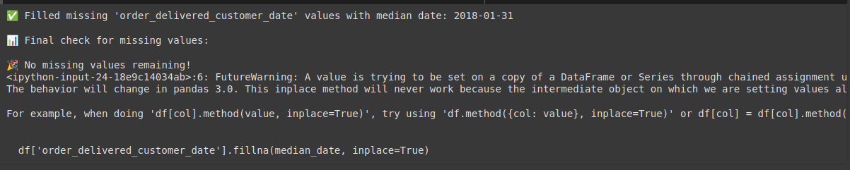

Step 4: Detecting of Duplicates Values:
To ensure data integrity, we checked for duplicate records:
duplicates = df.duplicated().sum()

Result: As in our case no duplicate value found.


Step 5: Outlier Detection
We used the IQR (Interquartile Range) method to detect outliers in numerical columns.
for col in ['price', 'payment_value']:
Q1 = df[col].quantile(0.25)
Q3 = df[col].quantile(0.75)
IQR = Q3 - Q1
lower = Q1 - 1.5 * IQR
upper = Q3 + 1.5 * IQR
df = df[(df[col] >= lower) & (df[col] <= upper)]

Outlier Detection
Outliers were found in the following columns:
price | 402
payment_value | 543

These numbers were obtained by comparing each data point to the 1.5 * IQR threshold for each numerical column.

Step 5: Outlier Handling (Impute method)
All identified outliers were removed from the dataset using conditional filtering based on IQR bounds.
# Impute outliers with the median value
median_value = df[column].median()
df_cleaned = df.copy()
df_cleaned[column] = df[column].apply(lambda x: median_value if x < lower or x > upper else x)

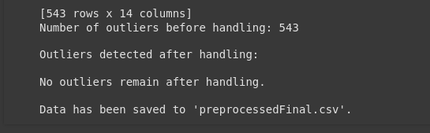

Rationale:
Removing outliers helps in reducing skewness and enhancing model accuracy.

Step 6: Saving (CSV File):
# Save the cleaned DataFrame to a new CSV file
df_cleaned.to_csv('preprocessedFinal.csv', index=False)
print("\nData has been saved to 'preprocessedFinal.csv'.")

Step 7: Final Confirmation (New Saved CSV File):
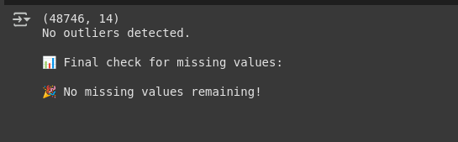

Why These Steps?
- Removing rows vs filling values: Removed when the missing data was excessive or crucial (like review_comment_message).
- Filling with median: Prevented bias that could occur with mean in skewed distributions.
- IQR for outliers: Robust method suitable for continuous features.

